**Extreme Sports Startup**

**Brand marketing campaign**

**Brand identity**

* Our new Camber and Rocker boards are less likely to catch an edge due to new technology - fully carbon fiber guts.
* Ever found a perfect snowboard design just to realize your size is not available? Not an issue. Choose the design you like - we will carve the size you want.
* Struggling to define what’s an All mountain? Freestyle? Freeride? Why would you go through all the hassle googling “difference between snowboard types”? - (Couple questions about where you ride, how you ride, experience, etc. that takes visitors to “Snowboards for you” page)

So we’re offering hassle free snowboard searching, all the sizes you can imagine (that’s rare) and we’re using new technologies to make catching edges not as easy (the biggest pain point of snowboarders)

**Brand messaging**

We're here to ensure you never have to compromise comfort or safety just to enjoy the adrenaline on the slopes. With our snowboards, you can experience that thrill without worrying about catching an edge. Whether you're an experienced rider or just starting out, our boards, the same ones you've seen at the X-Games, are designed for everyone. So forget about questioning if you're 'experienced enough' - with us, you're ready to ride!

**Visual identity**

Since it’s an extreme sports startup, bright colors should be used. There are lots of red/black/blue colors on competitors' color pallets. We can aim for a **bright green/black color** palette that would differentiate us solely from a color perspective. Speaking of logo, we should aim for something minimalistic, since the biggest competitors have that as well (left picture). Something in black and white, rough example on the right.

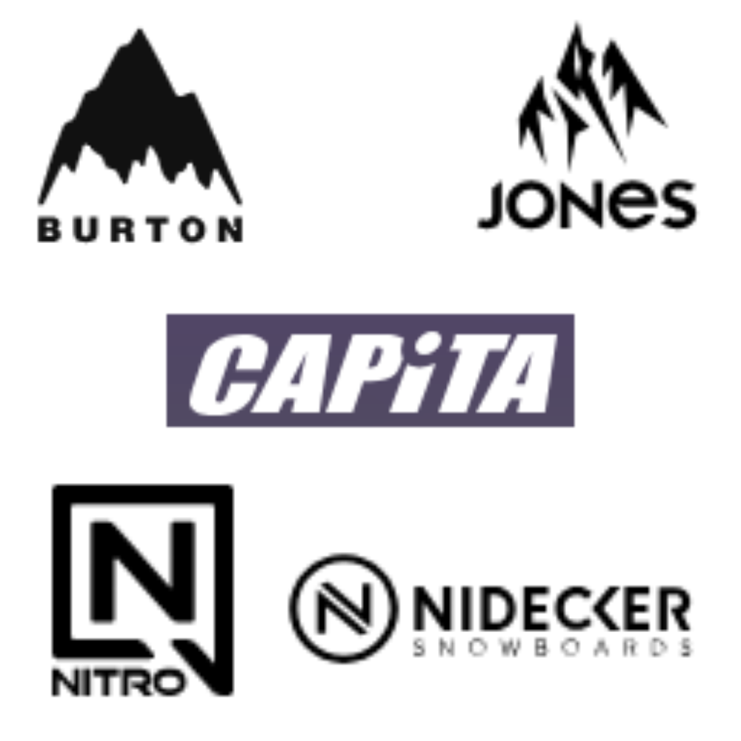

**Multi-Channel campaign**

* Collab with RedBull as they are very much involved in this sport scene - Exchange visual ads on social platforms, promote their brand by providing their energy drinks, RedBull flags and other visuals on live events.
* Collab with Dope Snow and Montecwear as they are booming right now (Snowboarding apparel and accessories) - Make mutual ads, meaning both our snowboards and their apparel is shown, there won’t be any conflict of interest if we collab with both companies, as it’s the same owner for both of these brands.
* Use social media both to showcase our snowboard debut in X-Games, regular snowboards usage on mountains, show the clips with collabs.
* Encourage people to submit their highlights with our snowboards to win prizes or store credit (Extra footage for us to use on our channels + UGC shared by followers at the same time)
* There are lots of youtubers/tiktokers/instagramers that we can collaborate with - for example Danny Davis, Katie Ormerod, Jamie Anderson. Combined they have over 1M Instagram followers, and the best part is, they are also sponsored by Redbull.
* Optimize SEO for organic reach
* Email marketing (Newsletters/Abandoned Cart/Discount after purchase campaigns)

Meta and X are not the desired platforms for our products, yet we can still show some presence here and decide if it’s worth the budget or time along the way. Also contact blog sites that review snowboards. Become a sponsor of as many ski resorts as possible, so our snowboards would be available for renting.

**Launch events**

Simply showcase our brand on season openings in ski resorts, especially if our snowboards are available to rent in that ski resort. Launch some kind of events - fastest lap wins, best trick wins, etc. Provide a clear schedule of dates and ski resorts where people can find us.

As mentioned above - we’re encouraging people to submit their highlights, so that’s kind of an event on its own. People are participating in competing for our prizes.

**Performance marketing campaign**

**KPI’s**

ROAS, CTR, Conversion rate, CPA, AOV, CPM, CPV and Engagement rate are essential to track. That’s quite simple since we’re selling online, we have all the data needed. We can track that with Google Analytics.

As we’re mostly focusing on social media, we need to track engagement rate in order to adapt our content, what’s working and what’s not, since that directly impacts our other metrics.

Email marketing should show us if our campaigns are working, are we doing good on the “Retention” part of the customer journey. For email marketing we also need to add Opened emails rate as a KPI.

What’s also important to track is how our collabs and renting in ski resorts are doing. We need pixels to track if our traffic is coming from the brands that we collaborated with. Also we need to check the ROI of ski resorts, how our renting model is performing there.

**Channel selection**

* Website (SEO) is essential for any brand in any niche, this gives results over time
* Email marketing to obtain new customers with newsletters and recurring customers with special offers after their purchase
* Instagram would be main social media used, due to versatility of showing videos/pictures or announcements in the story, direct link to website and our audience being present mostly on Instagram
* Tiktok will be used, but we won’t focus there too much, since the audience there might be too young (if we get decent KPI’s from Tiktok, we can focus more on there). Most content related to snowboarding on Tiktok is UGC, but not branded, so we will try to utilize that for videos submitted by our audience, not solely our created content.
* Meta and X will be used simply to have presence there and we will adapt along the way if we should focus more or ditch these channels
* Youtube of course, showcasing our snowboards with longer and informative videos
* Also social media channels like Youtube and Instagram will be used for our affiliates, influencers and UGC

**Budget allocation**

We will allocate 70% of the marketing budget to Performance marketing, 30% to Brand marketing at the beginning. First we need to understand the customer journey and have some data of our performance campaigns that are easier to track numerically. After that we can adapt the campaigns and make them more efficient without increasing the marketing budget, allocating more % towards Brand marketing.

Let’s say our marketing budget is 500 000 EUR, meaning 350 000 EUR towards performance marketing.

We use 15 000 EUR for SEO first, so we could start ranking organically over time.

We will spend 20 000 EUR for Email marketing during the campaign.

Tiktok, Meta and X will get 40 000 EUR combined at first, to test the channels, will increase or decrease the amount here over time.

Instagram being the main channel will get 50 000 EUR alone, for constant updates, fresh content, posting stories and interacting with the audience.

Youtube will get 15 000 EUR.

Since we have affiliates and influencers that are working with us, we will need to sponsor them with our gear, during the whole campaign we can easily say that adds up to 20 000 EUR.

After all this, we’re left with 190 000 EUR for our Performance marketing campaign. The biggest cost for whatever platform we’re using will be professional video creation, editing, flying to ski resorts to get the footage. So 190 000 EUR will be spent towards video/content production, that’s going to be used for all platforms mentioned above.

**Campaign execution**

* SEO first. We take care of our website SEO, we slowly start ranking and we “forget” about it. (By forget I mean we won’t be focusing too much here, change something once in a while).
* Email marketing is also active during the whole campaign. 3 campaigns to begin with - newsletter subscribers/abandoned cart/made a purchase, offering a special discount for them.
* Our Content creation team starts producing content for social media platforms, brainstorming ideas, graphics and copywriting. As our video makers provide the footage, we slowly start ramping up videos and pictures on social media.

We do a lot of testing, if pictures work great or we should stick to videos only, we do a lot of A/B testing to find what’s working.

At the same time we’re looking for influencers, collabs and affiliates to work with, that’s how we execute our campaigns on all social media.

**Optimization and analysis**

We will use Ahrefs and SEMrush to analyze SEO. We will adapt the bidding for right keywords according to the data.

We will use Hubspot for email marketing. A/B testing will help us decide how we should approach our campaigns.

To track our social media performance, we will use tools that measure engagement rate. By seeing what works and what doesn’t we can optimize our content accordingly.

For main KPI’s like ROAS, CTR, AOV, etc. we will look at our website’s data and Google Analytics, that not only gives us numbers on revenue, but also on traffic. What channel gives us the most traffic, sales and so on. The more data we get over time, the better we can optimize our campaigns along the way.